
Standard Operating Procedures



SOPs: Searching for Job

There are some procedures that needs to be followed whensearching for a job on upwork.
- Always apply on jobs that are newly uploaded. Do not apply on jobs that are uploaded 1 hour before.
Applicable to apply Do not apply

- Clearly read all the requirements written on job uploaded by client and if you cannot understand the job, check tags to see whether we can do this job or not.

- We cannot apply on jobs that are posted from
- India
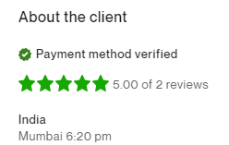
- Israel
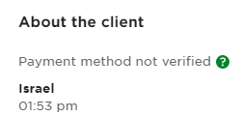
_{Do not Apply Do not Apply}

- When you see a job to apply on, check client membership on upwork. Do not apply when client is a new member on upwork.

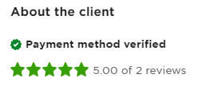
- Check the reviews of client. Do not apply when you find the reviews are less than 2 stars. Also look over the amount of money spent by the client to make sure whether the client is fake or not.
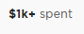

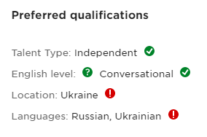
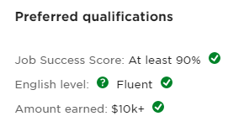
- Then check the preferred qualifications to see whether we are eligible to apply or not. Red mark means you are not eligible to apply.

Do not Apply Applicable to apply

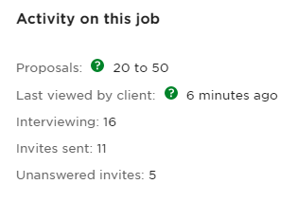
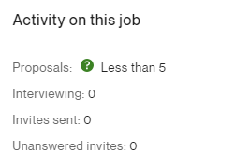
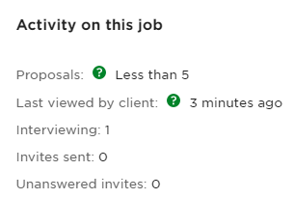
- Lastly check the activity on job to see how many proposals are already applied on it. If it is more than 50 proposals applied, than skip the job and do not apply on it.

Applicable to apply Do not apply

- After making sure all of the above point are in check, you are ready to submit the proposal.

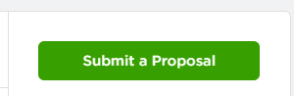

SOPs: Submit a Proposal
There are some procedures to follow when you are applying on a job.

- Introduce yourself with the cover letter that is made for the upwork profile.
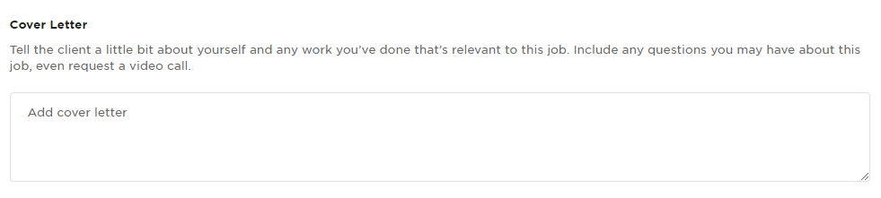

- The format for the proposal is
- First you have to add cover letter
- Secondly write a statement telling client that you have understood all the requirements
- Then ask questions regarding job, it is necessary to add questions in your proposal. You can write general questions like asking for business etc.
- Then add links of your previous websites developed.
- Then finally add a small statement asking for further discussion and always write warm regards with your name at the end.
- Now attach work samples too your proposal, it’s limit is only 10 pictures.
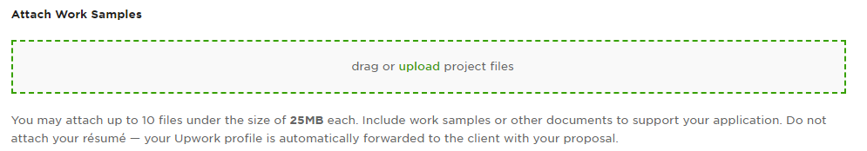
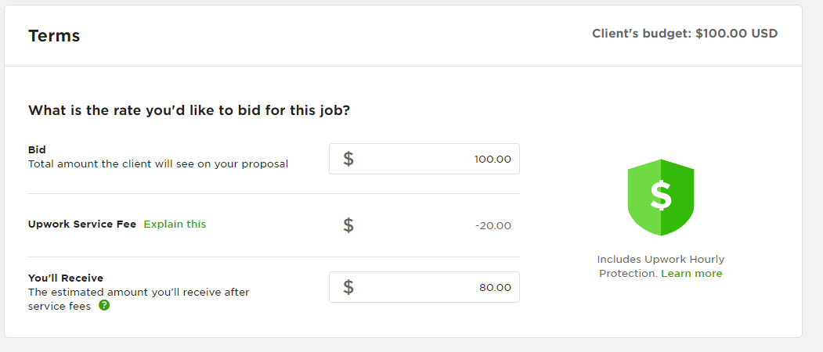
- Check client’s budget and then add your own budget.

- Add timeline for this project.
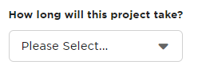

- Then you are ready to submit.

SOP: SEO Quote
These package are for SEO jobs.
- For Search engine optimization we have three packages that we have to tell our clients.
- First package is of 100usd per month, in this package we can integrate basic SEO and plugin in your website. We will also create some basic keywords. The max page quantity is 10 pages.
- The second package is of 200usd, We will create 3 keywords for your website and will do optimization of your whole website using those keywords. The max page quantity is 20 pages.
- The third package is of 300usd, the max page quantity is 50 pages. We will create 5 keywords and optimize the whole website using those keywords.

SOP: Speed Optimization
- The basic speed optimization will load with 50% speed on mobile and 60 to 70% on desktop in gmetrix ranking. This package is of 100usd.
- This package is of 200usd, in this you will get 70 to 80% speed on desktop and 60+ on mobile in gmetrix ranking.
- Third package is of 300usd, in this package you will get 80 to 90% speed on desktop and 70 to 80% on mobile according to gmetrix ranking.

SOP: WordPress Portfolio Website
We have 3 packages for WordPress portfolio website designing.
- In the first package we will create single page website for you with basic pages like contact, about us etc. The quote for this is 200usd. This will not include hosting and domain or any premium plugin or theme. We will do basic SEO in your website and will charge for additional changes like speed optimization etc. We will also provide 5 days of free support after the website is completed.
- In the second package we will create 5 pages for you. They can be team, services etc. Any 5 pages you require will be created. This will not include hosting and domain or any premium plugin or theme. The pricing vary from 300 to 350usd. We will do basic SEO in your website and will charge for additional changes like speed optimization etc. We will also provide 5 days of free support after the website is completed.
- In this package, we will make about 10 to 20 pages. These pages will include individual pages of your each service, team etc. We will also do basic SEO in this and basic speed optimization and will charge you for additional changes. We will also give you free support of 10 days after website is completed. The quote for this package vary from 500 to 600usd.

SOP E-Commerce Website
We have 3 packages for WordPress e-commerce website.
- The first package vary from 300 to 350usd. We will create basic pages for you and will integrate woo-commerce plus two payment methods of your choice. Will customize any theme of your choice and we will custom design pages. We will only add 20 products in your website. The hosting and domain or any premium plugin or theme will be purchased by client.
- The second package include 50 products in your website with basic SEO and SEM plus speed optimization. The theme will of your choice and we will customize it. The pricing of this package is 500 to 550usd. The hosting and domain or any premium plugin or theme will be purchased by client.
- This package will include 50+ products and we will also do social media integration of your products. When adding products it will generate a post on your social media accounts about your product. Having basic SEO, SEM and speed optimization. The pricing vary from 700 to 750 usd. The hosting and domain or any premium plugin or theme will be purchased by client.

SOP Website Maintenance
We have 3 packages for this project.
- This package include basics like trouble shooting maintenance and it will be 100usd per month. We will give you monthly report of the work.
- The second package will have troubleshooting plus improvement of your website. Improvement means if you want to add some new feature to your website or improve a previous functionality. The pricing vary from 150 to 200usd per month. We will give you monthly report of the work.
- This package include troubleshooting maintenance plus improvement and additional feature plus basic SEO. The pricing vary from 200 to 300usd. We will give you weekly report of the work.

SOP Application Developed over React Native
We provide end-to-end Android app development services from business analysis to delivering a ready-to-use Android app and putting it in good standing on Google Play Store. Following are our packages.
- The first package starts from $400, In this package we will provide you with a basic App. Delivery time will be 1 day and number of revisions will be 1. Number of operating systems for your App in this package will be 1. We will provide you icon for the App, Splash Screen and Ad Network Integration.
- The second package is of $2000. Delivery time for this app will be 6 days and number of revisions will be 3. Number of operating systems for your App in this package will be 1. We will provide you icon for the App, Splash Screen, Ad Network Integration and App Submission.
- The last package is of $5000. Delivery time for this app will be 9 day and number of revisions will be 5. Number of operating systems for your App in this package will be 2. We will provide you icon for the App, Splash Screen, Ad Network Integration, App Submission and Source Code.

SOP Android App development

We deliver apps to address the quickly changing technologies as well as your strategic business objectives through an innovative approach. Following are our packages.

The first package starts from $200. Delivery time will be 20 days and Number of Revisions will be 1. Operating system for this App will be 1. We will provide you with splash screen in your App.
- The second package is of $750. Delivery time for this app will be 24 days and number of revisions will be 1. Number of operating systems for your App in this package will be 2. We will provide you icon for the App and Splash Screen.
- The last package is of $999. Delivery time for this app will be 28 days and number of revisions will be 2. Number of operating systems for your App in this package will be 2. We will provide you icon for the App, Splash Screen, Ad Network Integration, App Submission and Source Code.

Custom Quote for Android App Development
These are some custom quotes for those clients who want to work hourly not on fixed price.
- If the clients wants to make a very small App for testing purpose minimum hours to quote would be 20 to 50hrs.
- If the clients wants to make a big Application then the quote would be stated as weekly or monthly, this will be decided after fully understanding the job and Application.
- If the client wants to make a basic App like integration App then we will quote 4 to 6 weeks to client and 20hrs/week.

SOP How to deal with Client
Sometimes Clients sends messages for custom quoting on their project we should respond them like. These instructions are for both App Development and Website Development.
- Firstly get all the information from the client by asking queries from him
- Then after we understand about the job check if the job matches with any of our packages.
- If it does not match with the packages then we’ll have to state custom quote for its project.
- We have to properly respond to client on time so that client knows that we are interested in its project.

